**Data Collection**

1. **Purpose**

The data in this section was collected to demonstrate the use and results of the Smart Parking mobile app on campus and the convenience it brings to faculty, staff and students.

1. **Methodology / Data sources**

Secondary data, collecting and screening academic papers from recent years and extracting data from them.

1. **Result**

Reducing traffic congestion minimizes fuel consumption. Smart parking systems can protect our environment by reducing pollutant emissions caused by fuel wasted looking for parking spaces. Figure 1 is a tree diagram of hypothetical fuel savings, and it is easy to see that fuel savings are increasing year over year.[1]

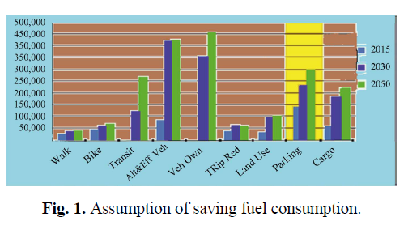

In Table 2, if drivers were provided with real-time parking information, the average search time would be reduced by 55.63%, the distance traveled would be reduced by 18.94%, and the fuel consumption would be reduced by 18.65%.[2]

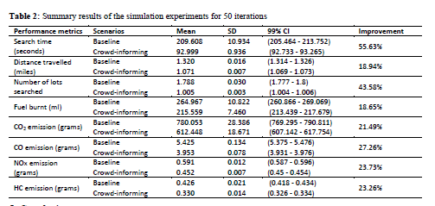

**Reference**

[1] A. Ahad, Z. R. Khan, and S. A. Ahmad, “Intelligent Parking System,” World J. Eng. Technol., vol. 4, pp. 160–167, 2016.

[2] Rahman, Md Mamunur, Mateo Anthony Galvez, and Yuan Zhou. "Evaluation of'Crowd-informing'on Parking Performance and Environmental Emissions: An Agent-Based Simulation of an Urban University Campus." IIE Annual Conference. Proceedings. Institute of Industrial and Systems Engineers (IISE), 2021.